Nuacht na Scoile
Deireadh Fomhair 2022
Principal’s Address
I would like to take this opportunity to welcome all our new staff, pupils and their families, I would like to welcome in a special way all our Ukrainian families to our school community. It is wonderful to see your sons integrate into our school and pick up the English language so efficiently!
This has been a busy half-term with chess clubs, board games clubs, football, prayer services, weekly assemblies, GAA and tag rugby coaching to name but a few and a lot more planned for the run up to Christmas!!
Have a lovely, safe Halloween break!
Le gach dea-ghuí
Padraig Ó Gealbháin
Meet the Staff
There have been a lot of changes to staff over the past few months so we will introduce everyone! A special welcome to all our new staff members!
We wish the teachers Ms Wright, Ms Cosgrove and Ms Burke all the best in their new schools closer to their homes.

Deputy Principal
Mr Stephen Terry
Principal
Mr Pat Galvin
Junior Infants
A Ms Shortall
B Ms Flanagan
C Ms Maher
Support teacher Ms Davis
Senior infants
A Ms B. Murphy
B Ms Ryan
C Ms Byrne
Support teacher Ms Kearney
1st class
A Ms Leahy
B Ms Fitzgibbon
C Mr O’Riordan
Support teacher Ms Dooley
2nd class
A Ms Guilfoyle
B Ms Culhane
C Ms Delaney
Support Teacher Ms Doran

3rd class
A Mr McKeon
B Ms Higgins
C Ms Williams
Support teacher Mr Hetherton
4th class
A Ms Menclikowska
B Mr O’Connor
C Ms Sullivan
Support teacher Ms Connolly
5th class
A Mr Minnock
B Ms Mooney
Support teacher Ms Meade
6th class
A Mr Purcell
B Mr Burbage
C Mr Cloherty
Support Teacher Ms Mortimer
Junior Ark
Mr Murrell
Senior Ark
Ms Murphy
Sonas Room
Ms McNabb
EAL Teacher
Ms Van Rijswijk
Supply Panel teachers
Mr McKessey
Ms Mitchell
Ms Draper
Special Needs Assistants
Myrna Kenny
Shelly Craig
Marie Therese O’Keeffe
Ann Dowling
Elena O’Hora
Shauna Fenlon
Kevin O’Rourke
Georgina Fitzpatrick
Sinead Pigott
Sharyn McHugh
Melanie Broderick
Amanda Dunne
Secretaries
Carmel Orford
Ailish Ridgeway
Caretaker
Eddie Downey
Cleaners
Valerie Carroll
Deirdre Connolly

Rainbows Programme
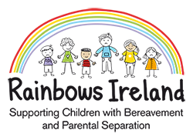
Scoil Phádraig are currently enrolling for the Rainbows programme. The Rainbows Programmes provide
• a 10-week listening, group support programme for children and young people following a bereavement or parental separation.
• Children of a similar age (from 7years) and loss experience are in separate groups.
• Rainbows is not counselling or professional therapy.
For further enquiries or to enrol your child: email rainbowsscoilphadraig@gmail.com or leave a message for Aisling Sullivan, Rainbows Co-Ordinator, Scoil Phádraig (057 8623394)
Nurture Group
Our school will be creating a nurture room after Halloween. This will be a focused, short-term intervention for boys with social, emotional and behavioural difficulties which make it harder for them to learn in a mainstream class.
The aim is to replace missing early experiences by developing positive pupil relationships with both teachers and peers in a supportive environment.
Shoebox appeal
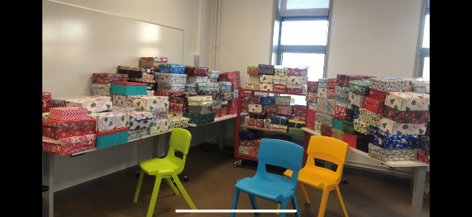
Boxes we gathered in 2019
This year our school will be participating in the ‘Shoebox appeal’. It is a great opportunity to give to those in need and talk to the boys about children in developing countries around the world. The closing date for the boxes is Tuesday 8th November 2022.
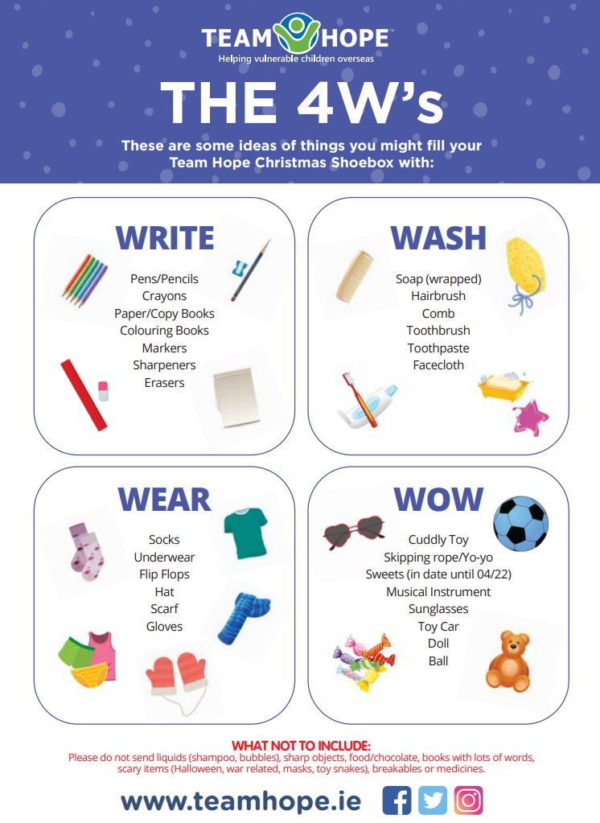
Some ideas above of what to include in the box!
Maths Week
The school celebrated maths week with lots of interactive and fun maths stations recently!
Tag Rugby
The boys from 3rd and 4th have had tag rugby coaching with Páidí for the last few weeks. The boys also got to partake in a tag rugby blitz against other schools recently! Great fub for all.
Coaching for 1st and 2nd will begin after Halloween.
Fire Safety
The fire officers from Portarlington Fire Station recently visited the school. They spoke to the younger boys about their job and the older boys about fire safety week.
Parent teacher meeting
Our parent teacher meetings will take place on Tuesday, November 29th , Wednesday, November 30th and Thursday, December 1st.
Your son’s class teacher will be in contact with your scheduled time and you may choose if you wish to meet face to face or receive a phone-call.
Sacramental Dates
First Confession – Mon, March 13th at 7.30
Confirmation - Thurs, March 23rd at 11
First Communion – Sat, May 20th at 11.30
Month of the Rosary
This month our boys are learning about how we pray the rosary. We are also praying the rosary together every day for a week to put our learning into practice. We are led daily by the boys from 5th and 6th class.
Back to school service
The school gathered in the hall in September to pray together and reflect o September being the month of creation. Fr Dooley led the service and the boys read prayers and reflections.
Bible Studies
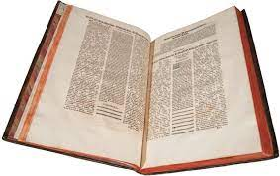
Ailish our school secretary is a bible study leader. She spoke to the boys from 6th class about the story of creation. The interest was so positive a weekly bible studies group has been formed and they will meet for the 6 weeks leading up to Christmas.
Student’s Council
Our new student council are up and running within the school. The boys are enthusiastically taking in the junior infants in the mornings, handing out the lunch bags, setting up school hall for different functions, helping out with the younger boys at break time to name but a few!
Culture Day
To celebrate culture day, we had a zoom call with Aneesa Franco, the Spanish artist that designed our school Trinity Loop. She explained the creative process and practical structural work involved in completing this master piece.
The boys then worked on their interpretation of the Trinity Loop with clay.
Agility Course
The school is currently in consultation with providers of playground equipment to create an agility course in our school garden.
Fundraising events will be on going in the coming months to support this.
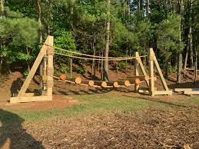
Open Night
Principal Mr Brown and Deputy Principal Ms O’Sullivan from Coláiste Íosagáin visited our school this week to meet their perspective 1st years 2023!!
Open Night for Coláiste Íosagáin is on Thursday, November 10th at 7pm.
Board Game Club
The boys from 3rd class have a 6 week after school board game club! Lovely to see them all playing the traditional games!
Halloween Dress Up
Our annual Halloween dress up will happen Friday, 28th of October. The boys are invited to dress up and bring in some sweets. We are asking that they bring in a €2 donation, and the proceeds will be donated to ‘Fight for Johnny’s Girls’*.
The younger classes will have a Halloween disco in the hall and the older class will watch a Halloween movie.
*Johnny is living in Australia, however he is native to Portarlington. He was diagnosed with ALS is a cruel Motor Neurone Disease and there is no cure. For further information visit their GoFundMe Fundraiser for Sherie McCowen by Johnny McCowen: Fight for Johnny's Girls (gofundme.com)
Chess Club
The chess club for the boys in 4th class began this term. The boys are really enjoying the experience.
Football
Our two school football teams have reached their respective Shield Finals. These will be played in O’Moore Park after Halloween. It is wonderful to see so many new players succeed and represent the school so well.

Football
The boys completed coaching sessions with Jamie over the last few weeks and this will continue after the midterm.
3rd and 4th will have the coaching this term too as tag rugby is finished for them and 1st and 2nd will stop as their tag rugby begins!
County Champs!
The manager and players of Portarlington GAA visited our school recently. The boys sang our Port song for them, interviewed the players and got the all-important autographs!! It was wonderful to have some past pupils through our door with the xxx cup! Best of Luck in Leinster boys!!
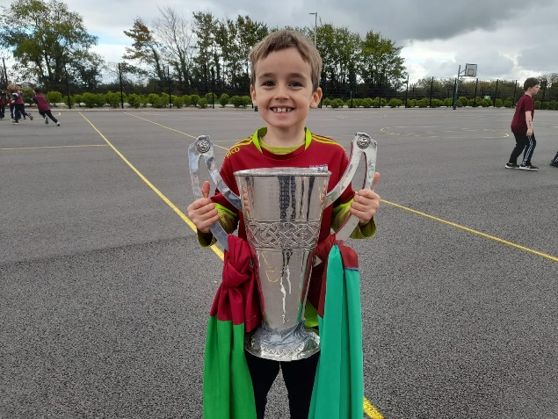
Congratulation
Congratulations to Ms Wyer on the safe arrival of her baby girl, Sophie.
Best of luck
We wish Ms Delaney all the best on her wedding day over the midterm break. Wishing you a lifetime of happiness.

Social Networks
We ask all parents to respect the confidentiality and privacy of our school community. We ask all parents to refrain from making any reference to our school, teacher, pupils or other parents on social media. Mr Galvin and the staff are always available to discuss any concerns you may have in relation to your son at short notice. We strongly encourage this mutual respect.
Holidays
We close tomorrow for our midterm break, October 28th at usual times.
School closure for the Christmas break on Thursday, December 22nd at 11.50.

